# CS 255 System Design Document Template

This template lays out all the different sections that you need to complete for Project Two. Each section has guidance to prompt your thinking. You will need to continually reference the interview transcript as you work to make sure that you are addressing your client’s needs. There is no required length for the final document. Instead the goal is to complete each section based on what your client’s needs are. Remove this note when you are finished, and replace all bracketed text with the relevant information.

## UML Diagrams

### UML Use Case Diagram

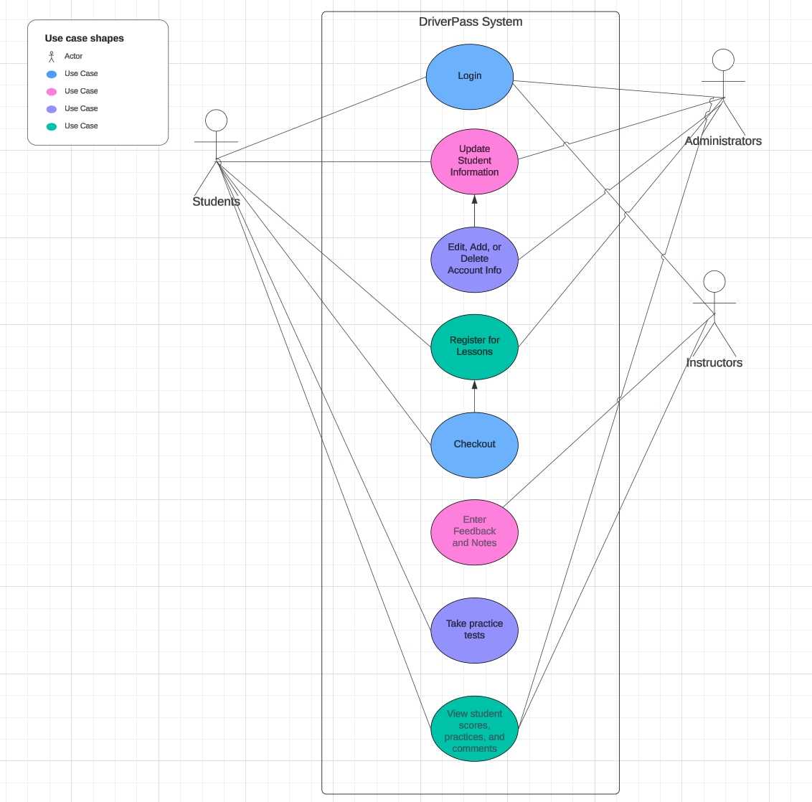

### UML Activity Diagrams

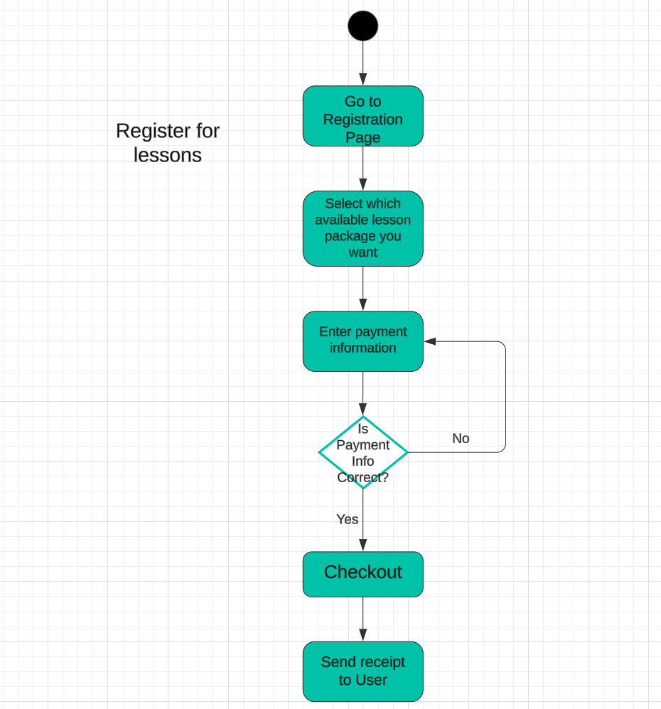

### UML Sequence Diagram

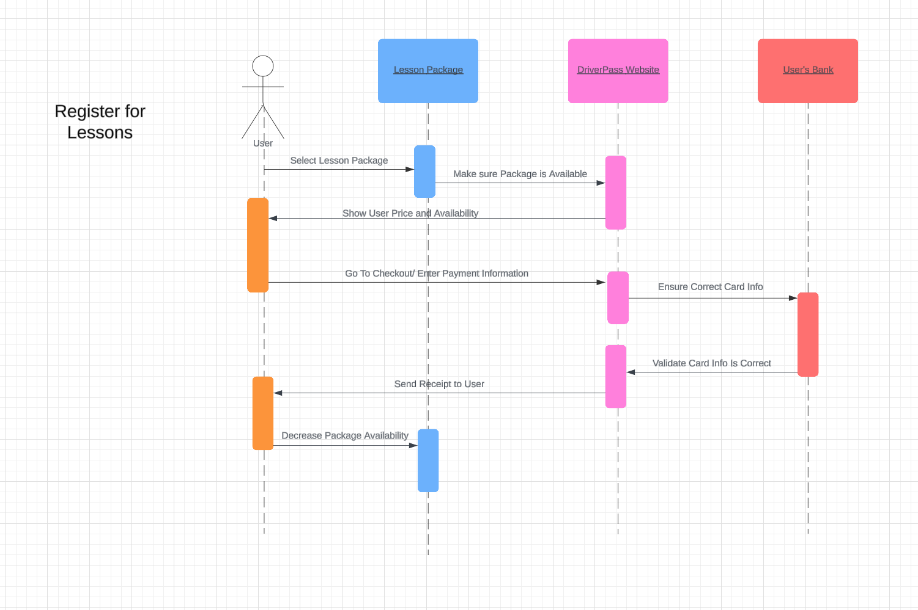

### UML Class Diagram

## Technical Requirements

*The DriverPass system will need several technical requirements, including specific hardware, software tools, and infrastructure. For example, several hardware requirements that this system will need include a server, a computer or phone that can access the website, and connection to the internet or Wi-Fi. In addition, there are several technical requirements regarding the software of the system. The system will need a database to store all the student information, as well as practice test information. The system will also need software security features to protect their user’s information. Lastly, infrastructure is also an important concept to consider when creating the system. The equipment used must be up-to-date and able to handle all the functionalities of the system. Consistent updates and fixes to the system will help keep the infrastructure working and efficient. It is important that users who sign up for lessons are within a certain geographic distance from instructors, as well as make sure they reside in an acceptable location, whether that be the United States or a specific state or states. The system also needs to be able to perform certain functions, such as allowing students to access practice tests and content and registering for in-person, on-the-road lesson packages.*